Competitive Shooters of Lake Norman 2025 Club Championship
COURSE DESIGNER: Ike Starnes
START POSITION: See written stage briefings.
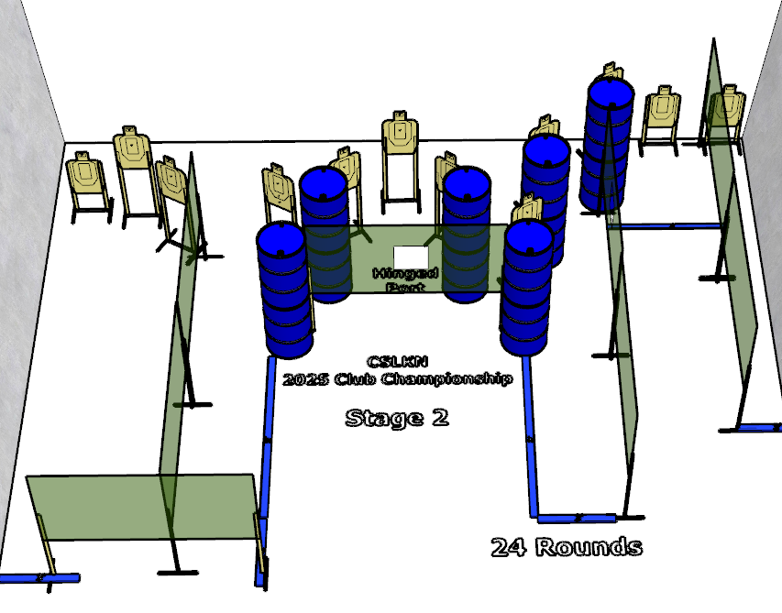

Written Stage Briefing:

Stage 2 - It's dark and we're wearing Sunglasses - is a 24-round, 120 point, Comstock Course. There are 12 cardboard targets and some noshoots. The best 2 hits per cardboard target will be scored.
Handgun start position Anywhere. The handgun is loaded and holstered.
PCC start position Anywhere. PCC is loaded with stock touching belt.
On the audible start signal, engage targets from within the shooting area.

